TimeSeriesII.R

**Vishal A. Ambavade**

Fri May 03 15:33:13 2019

**Q. Build a timeSeries object with the data.**

data("sunspots")  
sunspots

## Jan Feb Mar Apr May Jun Jul Aug Sep Oct Nov  
## 1749 58.0 62.6 70.0 55.7 85.0 83.5 94.8 66.3 75.9 75.5 158.6  
## 1750 73.3 75.9 89.2 88.3 90.0 100.0 85.4 103.0 91.2 65.7 63.3  
## 1751 70.0 43.5 45.3 56.4 60.7 50.7 66.3 59.8 23.5 23.2 28.5  
## 1752 35.0 50.0 71.0 59.3 59.7 39.6 78.4 29.3 27.1 46.6 37.6  
## 1753 44.0 32.0 45.7 38.0 36.0 31.7 22.2 39.0 28.0 25.0 20.0  
## 1754 0.0 3.0 1.7 13.7 20.7 26.7 18.8 12.3 8.2 24.1 13.2  
## 1755 10.2 11.2 6.8 6.5 0.0 0.0 8.6 3.2 17.8 23.7 6.8  
## 1756 12.5 7.1 5.4 9.4 12.5 12.9 3.6 6.4 11.8 14.3 17.0  
## 1757 14.1 21.2 26.2 30.0 38.1 12.8 25.0 51.3 39.7 32.5 64.7  
## 1758 37.6 52.0 49.0 72.3 46.4 45.0 44.0 38.7 62.5 37.7 43.0  
## 1759 48.3 44.0 46.8 47.0 49.0 50.0 51.0 71.3 77.2 59.7 46.3  
## 1760 67.3 59.5 74.7 58.3 72.0 48.3 66.0 75.6 61.3 50.6 59.7  
## 1761 70.0 91.0 80.7 71.7 107.2 99.3 94.1 91.1 100.7 88.7 89.7  
## 1762 43.8 72.8 45.7 60.2 39.9 77.1 33.8 67.7 68.5 69.3 77.8  
## 1763 56.5 31.9 34.2 32.9 32.7 35.8 54.2 26.5 68.1 46.3 60.9  
## 1764 59.7 59.7 40.2 34.4 44.3 30.0 30.0 30.0 28.2 28.0 26.0  
## 1765 24.0 26.0 25.0 22.0 20.2 20.0 27.0 29.7 16.0 14.0 14.0  
## 1766 12.0 11.0 36.6 6.0 26.8 3.0 3.3 4.0 4.3 5.0 5.7  
## 1767 27.4 30.0 43.0 32.9 29.8 33.3 21.9 40.8 42.7 44.1 54.7  
## 1768 53.5 66.1 46.3 42.7 77.7 77.4 52.6 66.8 74.8 77.8 90.6  
## 1769 73.9 64.2 64.3 96.7 73.6 94.4 118.6 120.3 148.8 158.2 148.1  
## 1770 104.0 142.5 80.1 51.0 70.1 83.3 109.8 126.3 104.4 103.6 132.2  
## 1771 36.0 46.2 46.7 64.9 152.7 119.5 67.7 58.5 101.4 90.0 99.7  
## 1772 100.9 90.8 31.1 92.2 38.0 57.0 77.3 56.2 50.5 78.6 61.3  
## 1773 54.6 29.0 51.2 32.9 41.1 28.4 27.7 12.7 29.3 26.3 40.9  
## 1774 46.8 65.4 55.7 43.8 51.3 28.5 17.5 6.6 7.9 14.0 17.7  
## 1775 4.4 0.0 11.6 11.2 3.9 12.3 1.0 7.9 3.2 5.6 15.1  
## 1776 21.7 11.6 6.3 21.8 11.2 19.0 1.0 24.2 16.0 30.0 35.0  
## 1777 45.0 36.5 39.0 95.5 80.3 80.7 95.0 112.0 116.2 106.5 146.0  
## 1778 177.3 109.3 134.0 145.0 238.9 171.6 153.0 140.0 171.7 156.3 150.3  
## 1779 114.7 165.7 118.0 145.0 140.0 113.7 143.0 112.0 111.0 124.0 114.0  
## 1780 70.0 98.0 98.0 95.0 107.2 88.0 86.0 86.0 93.7 77.0 60.0  
## 1781 98.7 74.7 53.0 68.3 104.7 97.7 73.5 66.0 51.0 27.3 67.0  
## 1782 54.0 37.5 37.0 41.0 54.3 38.0 37.0 44.0 34.0 23.2 31.5  
## 1783 28.0 38.7 26.7 28.3 23.0 25.2 32.2 20.0 18.0 8.0 15.0  
## 1784 13.0 8.0 11.0 10.0 6.0 9.0 6.0 10.0 10.0 8.0 17.0  
## 1785 6.5 8.0 9.0 15.7 20.7 26.3 36.3 20.0 32.0 47.2 40.2  
## 1786 37.2 47.6 47.7 85.4 92.3 59.0 83.0 89.7 111.5 112.3 116.0  
## 1787 134.7 106.0 87.4 127.2 134.8 99.2 128.0 137.2 157.3 157.0 141.5  
## 1788 138.0 129.2 143.3 108.5 113.0 154.2 141.5 136.0 141.0 142.0 94.7  
## 1789 114.0 125.3 120.0 123.3 123.5 120.0 117.0 103.0 112.0 89.7 134.0  
## 1790 103.0 127.5 96.3 94.0 93.0 91.0 69.3 87.0 77.3 84.3 82.0  
## 1791 72.7 62.0 74.0 77.2 73.7 64.2 71.0 43.0 66.5 61.7 67.0  
## 1792 58.0 64.0 63.0 75.7 62.0 61.0 45.8 60.0 59.0 59.0 57.0  
## 1793 56.0 55.0 55.5 53.0 52.3 51.0 50.0 29.3 24.0 47.0 44.0  
## 1794 45.0 44.0 38.0 28.4 55.7 41.5 41.0 40.0 11.1 28.5 67.4  
## 1795 21.4 39.9 12.6 18.6 31.0 17.1 12.9 25.7 13.5 19.5 25.0  
## 1796 22.0 23.8 15.7 31.7 21.0 6.7 26.9 1.5 18.4 11.0 8.4  
## 1797 14.4 4.2 4.0 4.0 7.3 11.1 4.3 6.0 5.7 6.9 5.8  
## 1798 2.0 4.0 12.4 1.1 0.0 0.0 0.0 3.0 2.4 1.5 12.5  
## 1799 1.6 12.6 21.7 8.4 8.2 10.6 2.1 0.0 0.0 4.6 2.7  
## 1800 6.9 9.3 13.9 0.0 5.0 23.7 21.0 19.5 11.5 12.3 10.5  
## 1801 27.0 29.0 30.0 31.0 32.0 31.2 35.0 38.7 33.5 32.6 39.8  
## 1802 47.8 47.0 40.8 42.0 44.0 46.0 48.0 50.0 51.8 38.5 34.5  
## 1803 50.0 50.8 29.5 25.0 44.3 36.0 48.3 34.1 45.3 54.3 51.0  
## 1804 45.3 48.3 48.0 50.6 33.4 34.8 29.8 43.1 53.0 62.3 61.0  
## 1805 61.0 44.1 51.4 37.5 39.0 40.5 37.6 42.7 44.4 29.4 41.0  
## 1806 39.0 29.6 32.7 27.7 26.4 25.6 30.0 26.3 24.0 27.0 25.0  
## 1807 12.0 12.2 9.6 23.8 10.0 12.0 12.7 12.0 5.7 8.0 2.6  
## 1808 0.0 4.5 0.0 12.3 13.5 13.5 6.7 8.0 11.7 4.7 10.5  
## 1809 7.2 9.2 0.9 2.5 2.0 7.7 0.3 0.2 0.4 0.0 0.0  
## 1810 0.0 0.0 0.0 0.0 0.0 0.0 0.0 0.0 0.0 0.0 0.0  
## 1811 0.0 0.0 0.0 0.0 0.0 0.0 6.6 0.0 2.4 6.1 0.8  
## 1812 11.3 1.9 0.7 0.0 1.0 1.3 0.5 15.6 5.2 3.9 7.9  
## 1813 0.0 10.3 1.9 16.6 5.5 11.2 18.3 8.4 15.3 27.8 16.7  
## 1814 22.2 12.0 5.7 23.8 5.8 14.9 18.5 2.3 8.1 19.3 14.5  
## 1815 19.2 32.2 26.2 31.6 9.8 55.9 35.5 47.2 31.5 33.5 37.2  
## 1816 26.3 68.8 73.7 58.8 44.3 43.6 38.8 23.2 47.8 56.4 38.1  
## 1817 36.4 57.9 96.2 26.4 21.2 40.0 50.0 45.0 36.7 25.6 28.9  
## 1818 34.9 22.4 25.4 34.5 53.1 36.4 28.0 31.5 26.1 31.7 10.9  
## 1819 32.5 20.7 3.7 20.2 19.6 35.0 31.4 26.1 14.9 27.5 25.1  
## 1820 19.2 26.6 4.5 19.4 29.3 10.8 20.6 25.9 5.2 9.0 7.9  
## 1821 21.5 4.3 5.7 9.2 1.7 1.8 2.5 4.8 4.4 18.8 4.4  
## 1822 0.0 0.9 16.1 13.5 1.5 5.6 7.9 2.1 0.0 0.4 0.0  
## 1823 0.0 0.0 0.6 0.0 0.0 0.0 0.5 0.0 0.0 0.0 0.0  
## 1824 21.6 10.8 0.0 19.4 2.8 0.0 0.0 1.4 20.5 25.2 0.0  
## 1825 5.0 15.5 22.4 3.8 15.4 15.4 30.9 25.4 15.7 15.6 11.7  
## 1826 17.7 18.2 36.7 24.0 32.4 37.1 52.5 39.6 18.9 50.6 39.5  
## 1827 34.6 47.4 57.8 46.0 56.3 56.7 42.9 53.7 49.6 57.2 48.2  
## 1828 52.8 64.4 65.0 61.1 89.1 98.0 54.3 76.4 50.4 54.7 57.0  
## 1829 43.0 49.4 72.3 95.0 67.5 73.9 90.8 78.3 52.8 57.2 67.6  
## 1830 52.2 72.1 84.6 107.1 66.3 65.1 43.9 50.7 62.1 84.4 81.2  
## 1831 47.5 50.1 93.4 54.6 38.1 33.4 45.2 54.9 37.9 46.2 43.5  
## 1832 30.9 55.5 55.1 26.9 41.3 26.7 13.9 8.9 8.2 21.1 14.3  
## 1833 11.3 14.9 11.8 2.8 12.9 1.0 7.0 5.7 11.6 7.5 5.9  
## 1834 4.9 18.1 3.9 1.4 8.8 7.8 8.7 4.0 11.5 24.8 30.5  
## 1835 7.5 24.5 19.7 61.5 43.6 33.2 59.8 59.0 100.8 95.2 100.0  
## 1836 88.6 107.6 98.1 142.9 111.4 124.7 116.7 107.8 95.1 137.4 120.9  
## 1837 188.0 175.6 134.6 138.2 111.3 158.0 162.8 134.0 96.3 123.7 107.0  
## 1838 144.9 84.8 140.8 126.6 137.6 94.5 108.2 78.8 73.6 90.8 77.4  
## 1839 107.6 102.5 77.7 61.8 53.8 54.6 84.7 131.2 132.7 90.8 68.8  
## 1840 81.2 87.7 55.5 65.9 69.2 48.5 60.7 57.8 74.0 49.8 54.3  
## 1841 24.0 29.9 29.7 42.6 67.4 55.7 30.8 39.3 35.1 28.5 19.8  
## 1842 20.4 22.1 21.7 26.9 24.9 20.5 12.6 26.5 18.5 38.1 40.5  
## 1843 13.3 3.5 8.3 8.8 21.1 10.5 9.5 11.8 4.2 5.3 19.1  
## 1844 9.4 14.7 13.6 20.8 12.0 3.7 21.2 23.9 6.9 21.5 10.7  
## 1845 25.7 43.6 43.3 56.9 47.8 31.1 30.6 32.3 29.6 40.7 39.4  
## 1846 38.7 51.0 63.9 69.2 59.9 65.1 46.5 54.8 107.1 55.9 60.4  
## 1847 62.6 44.9 85.7 44.7 75.4 85.3 52.2 140.6 161.2 180.4 138.9  
## 1848 159.1 111.8 108.9 107.1 102.2 123.8 139.2 132.5 100.3 132.4 114.6  
## 1849 156.7 131.7 96.5 102.5 80.6 81.2 78.0 61.3 93.7 71.5 99.7  
## 1850 78.0 89.4 82.6 44.1 61.6 70.0 39.1 61.6 86.2 71.0 54.8  
## 1851 75.5 105.4 64.6 56.5 62.6 63.2 36.1 57.4 67.9 62.5 50.9  
## 1852 68.4 67.5 61.2 65.4 54.9 46.9 42.0 39.7 37.5 67.3 54.3  
## 1853 41.1 42.9 37.7 47.6 34.7 40.0 45.9 50.4 33.5 42.3 28.8  
## 1854 15.4 20.0 20.7 26.4 24.0 21.1 18.7 15.8 22.4 12.7 28.2  
## 1855 12.3 11.4 17.4 4.4 9.1 5.3 0.4 3.1 0.0 9.7 4.3  
## 1856 0.5 4.9 0.4 6.5 0.0 5.0 4.6 5.9 4.4 4.5 7.7  
## 1857 13.7 7.4 5.2 11.1 29.2 16.0 22.2 16.9 42.4 40.6 31.4  
## 1858 39.0 34.9 57.5 38.3 41.4 44.5 56.7 55.3 80.1 91.2 51.9  
## 1859 83.7 87.6 90.3 85.7 91.0 87.1 95.2 106.8 105.8 114.6 97.2  
## 1860 81.5 88.0 98.9 71.4 107.1 108.6 116.7 100.3 92.2 90.1 97.9  
## 1861 62.3 77.8 101.0 98.5 56.8 87.8 78.0 82.5 79.9 67.2 53.7  
## 1862 63.1 64.5 43.6 53.7 64.4 84.0 73.4 62.5 66.6 42.0 50.6  
## 1863 48.3 56.7 66.4 40.6 53.8 40.8 32.7 48.1 22.0 39.9 37.7  
## 1864 57.7 47.1 66.3 35.8 40.6 57.8 54.7 54.8 28.5 33.9 57.6  
## 1865 48.7 39.3 39.5 29.4 34.5 33.6 26.8 37.8 21.6 17.1 24.6  
## 1866 31.6 38.4 24.6 17.6 12.9 16.5 9.3 12.7 7.3 14.1 9.0  
## 1867 0.0 0.7 9.2 5.1 2.9 1.5 5.0 4.9 9.8 13.5 9.3  
## 1868 15.6 15.8 26.5 36.6 26.7 31.1 28.6 34.4 43.8 61.7 59.1  
## 1869 60.9 59.3 52.7 41.0 104.0 108.4 59.2 79.6 80.6 59.4 77.4  
## 1870 77.3 114.9 159.4 160.0 176.0 135.6 132.4 153.8 136.0 146.4 147.5  
## 1871 88.3 125.3 143.2 162.4 145.5 91.7 103.0 110.0 80.3 89.0 105.4  
## 1872 79.5 120.1 88.4 102.1 107.6 109.9 105.5 92.9 114.6 103.5 112.0  
## 1873 86.7 107.0 98.3 76.2 47.9 44.8 66.9 68.2 47.5 47.4 55.4  
## 1874 60.8 64.2 46.4 32.0 44.6 38.2 67.8 61.3 28.0 34.3 28.9  
## 1875 14.6 22.2 33.8 29.1 11.5 23.9 12.5 14.6 2.4 12.7 17.7  
## 1876 14.3 15.0 31.2 2.3 5.1 1.6 15.2 8.8 9.9 14.3 9.9  
## 1877 24.4 8.7 11.7 15.8 21.2 13.4 5.9 6.3 16.4 6.7 14.5  
## 1878 3.3 6.0 7.8 0.1 5.8 6.4 0.1 0.0 5.3 1.1 4.1  
## 1879 0.8 0.6 0.0 6.2 2.4 4.8 7.5 10.7 6.1 12.3 12.9  
## 1880 24.0 27.5 19.5 19.3 23.5 34.1 21.9 48.1 66.0 43.0 30.7  
## 1881 36.4 53.2 51.5 51.7 43.5 60.5 76.9 58.0 53.2 64.0 54.8  
## 1882 45.0 69.3 67.5 95.8 64.1 45.2 45.4 40.4 57.7 59.2 84.4  
## 1883 60.6 46.9 42.8 82.1 32.1 76.5 80.6 46.0 52.6 83.8 84.5  
## 1884 91.5 86.9 86.8 76.1 66.5 51.2 53.1 55.8 61.9 47.8 36.6  
## 1885 42.8 71.8 49.8 55.0 73.0 83.7 66.5 50.0 39.6 38.7 33.3  
## 1886 29.9 25.9 57.3 43.7 30.7 27.1 30.3 16.9 21.4 8.6 0.3  
## 1887 10.3 13.2 4.2 6.9 20.0 15.7 23.3 21.4 7.4 6.6 6.9  
## 1888 12.7 7.1 7.8 5.1 7.0 7.1 3.1 2.8 8.8 2.1 10.7  
## 1889 0.8 8.5 7.0 4.3 2.4 6.4 9.7 20.6 6.5 2.1 0.2  
## 1890 5.3 0.6 5.1 1.6 4.8 1.3 11.6 8.5 17.2 11.2 9.6  
## 1891 13.5 22.2 10.4 20.5 41.1 48.3 58.8 33.2 53.8 51.5 41.9  
## 1892 69.1 75.6 49.9 69.6 79.6 76.3 76.8 101.4 62.8 70.5 65.4  
## 1893 75.0 73.0 65.7 88.1 84.7 88.2 88.8 129.2 77.9 79.7 75.1  
## 1894 83.2 84.6 52.3 81.6 101.2 98.9 106.0 70.3 65.9 75.5 56.6  
## 1895 63.3 67.2 61.0 76.9 67.5 71.5 47.8 68.9 57.7 67.9 47.2  
## 1896 29.0 57.4 52.0 43.8 27.7 49.0 45.0 27.2 61.3 28.4 38.0  
## 1897 40.6 29.4 29.1 31.0 20.0 11.3 27.6 21.8 48.1 14.3 8.4  
## 1898 30.2 36.4 38.3 14.5 25.8 22.3 9.0 31.4 34.8 34.4 30.9  
## 1899 19.5 9.2 18.1 14.2 7.7 20.5 13.5 2.9 8.4 13.0 7.8  
## 1900 9.4 13.6 8.6 16.0 15.2 12.1 8.3 4.3 8.3 12.9 4.5  
## 1901 0.2 2.4 4.5 0.0 10.2 5.8 0.7 1.0 0.6 3.7 3.8  
## 1902 5.2 0.0 12.4 0.0 2.8 1.4 0.9 2.3 7.6 16.3 10.3  
## 1903 8.3 17.0 13.5 26.1 14.6 16.3 27.9 28.8 11.1 38.9 44.5  
## 1904 31.6 24.5 37.2 43.0 39.5 41.9 50.6 58.2 30.1 54.2 38.0  
## 1905 54.8 85.8 56.5 39.3 48.0 49.0 73.0 58.8 55.0 78.7 107.2  
## 1906 45.5 31.3 64.5 55.3 57.7 63.2 103.6 47.7 56.1 17.8 38.9  
## 1907 76.4 108.2 60.7 52.6 42.9 40.4 49.7 54.3 85.0 65.4 61.5  
## 1908 39.2 33.9 28.7 57.6 40.8 48.1 39.5 90.5 86.9 32.3 45.5  
## 1909 56.7 46.6 66.3 32.3 36.0 22.6 35.8 23.1 38.8 58.4 55.8  
## 1910 26.4 31.5 21.4 8.4 22.2 12.3 14.1 11.5 26.2 38.3 4.9  
## 1911 3.4 9.0 7.8 16.5 9.0 2.2 3.5 4.0 4.0 2.6 4.2  
## 1912 0.3 0.0 4.9 4.5 4.4 4.1 3.0 0.3 9.5 4.6 1.1  
## 1913 2.3 2.9 0.5 0.9 0.0 0.0 1.7 0.2 1.2 3.1 0.7  
## 1914 2.8 2.6 3.1 17.3 5.2 11.4 5.4 7.7 12.7 8.2 16.4  
## 1915 23.0 42.3 38.8 41.3 33.0 68.8 71.6 69.6 49.5 53.5 42.5  
## 1916 45.3 55.4 67.0 71.8 74.5 67.7 53.5 35.2 45.1 50.7 65.6  
## 1917 74.7 71.9 94.8 74.7 114.1 114.9 119.8 154.5 129.4 72.2 96.4  
## 1918 96.0 65.3 72.2 80.5 76.7 59.4 107.6 101.7 79.9 85.0 83.4  
## 1919 48.1 79.5 66.5 51.8 88.1 111.2 64.7 69.0 54.7 52.8 42.0  
## 1920 51.1 53.9 70.2 14.8 33.3 38.7 27.5 19.2 36.3 49.6 27.2  
## 1921 31.5 28.3 26.7 32.4 22.2 33.7 41.9 22.8 17.8 18.2 17.8  
## 1922 11.8 26.4 54.7 11.0 8.0 5.8 10.9 6.5 4.7 6.2 7.4  
## 1923 4.5 1.5 3.3 6.1 3.2 9.1 3.5 0.5 13.2 11.6 10.0  
## 1924 0.5 5.1 1.8 11.3 20.8 24.0 28.1 19.3 25.1 25.6 22.5  
## 1925 5.5 23.2 18.0 31.7 42.8 47.5 38.5 37.9 60.2 69.2 58.6  
## 1926 71.8 70.0 62.5 38.5 64.3 73.5 52.3 61.6 60.8 71.5 60.5  
## 1927 81.6 93.0 69.6 93.5 79.1 59.1 54.9 53.8 68.4 63.1 67.2  
## 1928 83.5 73.5 85.4 80.6 76.9 91.4 98.0 83.8 89.7 61.4 50.3  
## 1929 68.9 64.1 50.2 52.8 58.2 71.9 70.2 65.8 34.4 54.0 81.1  
## 1930 65.3 49.2 35.0 38.2 36.8 28.8 21.9 24.9 32.1 34.4 35.6  
## 1931 14.6 43.1 30.0 31.2 24.6 15.3 17.4 13.0 19.0 10.0 18.7  
## 1932 12.1 10.6 11.2 11.2 17.9 22.2 9.6 6.8 4.0 8.9 8.2  
## 1933 12.3 22.2 10.1 2.9 3.2 5.2 2.8 0.2 5.1 3.0 0.6  
## 1934 3.4 7.8 4.3 11.3 19.7 6.7 9.3 8.3 4.0 5.7 8.7  
## 1935 18.9 20.5 23.1 12.2 27.3 45.7 33.9 30.1 42.1 53.2 64.2  
## 1936 62.8 74.3 77.1 74.9 54.6 70.0 52.3 87.0 76.0 89.0 115.4  
## 1937 132.5 128.5 83.9 109.3 116.7 130.3 145.1 137.7 100.7 124.9 74.4  
## 1938 98.4 119.2 86.5 101.0 127.4 97.5 165.3 115.7 89.6 99.1 122.2  
## 1939 80.3 77.4 64.6 109.1 118.3 101.0 97.6 105.8 112.6 88.1 68.1  
## 1940 50.5 59.4 83.3 60.7 54.4 83.9 67.5 105.5 66.5 55.0 58.4  
## 1941 45.6 44.5 46.4 32.8 29.5 59.8 66.9 60.0 65.9 46.3 38.3  
## 1942 35.6 52.8 54.2 60.7 25.0 11.4 17.7 20.2 17.2 19.2 30.7  
## 1943 12.4 28.9 27.4 26.1 14.1 7.6 13.2 19.4 10.0 7.8 10.2  
## 1944 3.7 0.5 11.0 0.3 2.5 5.0 5.0 16.7 14.3 16.9 10.8  
## 1945 18.5 12.7 21.5 32.0 30.6 36.2 42.6 25.9 34.9 68.8 46.0  
## 1946 47.6 86.2 76.6 75.7 84.9 73.5 116.2 107.2 94.4 102.3 123.8  
## 1947 115.7 113.4 129.8 149.8 201.3 163.9 157.9 188.8 169.4 163.6 128.0  
## 1948 108.5 86.1 94.8 189.7 174.0 167.8 142.2 157.9 143.3 136.3 95.8  
## 1949 119.1 182.3 157.5 147.0 106.2 121.7 125.8 123.8 145.3 131.6 143.5  
## 1950 101.6 94.8 109.7 113.4 106.2 83.6 91.0 85.2 51.3 61.4 54.8  
## 1951 59.9 59.9 59.9 92.9 108.5 100.6 61.5 61.0 83.1 51.6 52.4  
## 1952 40.7 22.7 22.0 29.1 23.4 36.4 39.3 54.9 28.2 23.8 22.1  
## 1953 26.5 3.9 10.0 27.8 12.5 21.8 8.6 23.5 19.3 8.2 1.6  
## 1954 0.2 0.5 10.9 1.8 0.8 0.2 4.8 8.4 1.5 7.0 9.2  
## 1955 23.1 20.8 4.9 11.3 28.9 31.7 26.7 40.7 42.7 58.5 89.2  
## 1956 73.6 124.0 118.4 110.7 136.6 116.6 129.1 169.6 173.2 155.3 201.3  
## 1957 165.0 130.2 157.4 175.2 164.6 200.7 187.2 158.0 235.8 253.8 210.9  
## 1958 202.5 164.9 190.7 196.0 175.3 171.5 191.4 200.2 201.2 181.5 152.3  
## 1959 217.4 143.1 185.7 163.3 172.0 168.7 149.6 199.6 145.2 111.4 124.0  
## 1960 146.3 106.0 102.2 122.0 119.6 110.2 121.7 134.1 127.2 82.8 89.6  
## 1961 57.9 46.1 53.0 61.4 51.0 77.4 70.2 55.9 63.6 37.7 32.6  
## 1962 38.7 50.3 45.6 46.4 43.7 42.0 21.8 21.8 51.3 39.5 26.9  
## 1963 19.8 24.4 17.1 29.3 43.0 35.9 19.6 33.2 38.8 35.3 23.4  
## 1964 15.3 17.7 16.5 8.6 9.5 9.1 3.1 9.3 4.7 6.1 7.4  
## 1965 17.5 14.2 11.7 6.8 24.1 15.9 11.9 8.9 16.8 20.1 15.8  
## 1966 28.2 24.4 25.3 48.7 45.3 47.7 56.7 51.2 50.2 57.2 57.2  
## 1967 110.9 93.6 111.8 69.5 86.5 67.3 91.5 107.2 76.8 88.2 94.3  
## 1968 121.8 111.9 92.2 81.2 127.2 110.3 96.1 109.3 117.2 107.7 86.0  
## 1969 104.4 120.5 135.8 106.8 120.0 106.0 96.8 98.0 91.3 95.7 93.5  
## 1970 111.5 127.8 102.9 109.5 127.5 106.8 112.5 93.0 99.5 86.6 95.2  
## 1971 91.3 79.0 60.7 71.8 57.5 49.8 81.0 61.4 50.2 51.7 63.2  
## 1972 61.5 88.4 80.1 63.2 80.5 88.0 76.5 76.8 64.0 61.3 41.6  
## 1973 43.4 42.9 46.0 57.7 42.4 39.5 23.1 25.6 59.3 30.7 23.9  
## 1974 27.6 26.0 21.3 40.3 39.5 36.0 55.8 33.6 40.2 47.1 25.0  
## 1975 18.9 11.5 11.5 5.1 9.0 11.4 28.2 39.7 13.9 9.1 19.4  
## 1976 8.1 4.3 21.9 18.8 12.4 12.2 1.9 16.4 13.5 20.6 5.2  
## 1977 16.4 23.1 8.7 12.9 18.6 38.5 21.4 30.1 44.0 43.8 29.1  
## 1978 51.9 93.6 76.5 99.7 82.7 95.1 70.4 58.1 138.2 125.1 97.9  
## 1979 166.6 137.5 138.0 101.5 134.4 149.5 159.4 142.2 188.4 186.2 183.3  
## 1980 159.6 155.0 126.2 164.1 179.9 157.3 136.3 135.4 155.0 164.7 147.9  
## 1981 114.0 141.3 135.5 156.4 127.5 90.0 143.8 158.7 167.3 162.4 137.5  
## 1982 111.2 163.6 153.8 122.0 82.2 110.4 106.1 107.6 118.8 94.7 98.1  
## 1983 84.3 51.0 66.5 80.7 99.2 91.1 82.2 71.8 50.3 55.8 33.3  
## Dec  
## 1749 85.2  
## 1750 75.4  
## 1751 44.0  
## 1752 40.0  
## 1753 6.7  
## 1754 4.2  
## 1755 20.0  
## 1756 9.4  
## 1757 33.5  
## 1758 43.0  
## 1759 57.0  
## 1760 61.0  
## 1761 46.0  
## 1762 77.2  
## 1763 61.4  
## 1764 25.7  
## 1765 13.0  
## 1766 19.2  
## 1767 53.3  
## 1768 111.8  
## 1769 112.0  
## 1770 102.3  
## 1771 95.7  
## 1772 64.0  
## 1773 43.2  
## 1774 12.2  
## 1775 7.9  
## 1776 40.0  
## 1777 157.3  
## 1778 105.0  
## 1779 110.0  
## 1780 58.7  
## 1781 35.2  
## 1782 30.0  
## 1783 10.5  
## 1784 14.0  
## 1785 27.3  
## 1786 112.7  
## 1787 174.0  
## 1788 129.5  
## 1789 135.5  
## 1790 74.0  
## 1791 66.0  
## 1792 56.0  
## 1793 45.7  
## 1794 51.4  
## 1795 18.0  
## 1796 5.1  
## 1797 3.0  
## 1798 9.9  
## 1799 8.6  
## 1800 40.1  
## 1801 48.2  
## 1802 50.0  
## 1803 48.0  
## 1804 60.0  
## 1805 38.3  
## 1806 24.0  
## 1807 0.0  
## 1808 12.3  
## 1809 0.0  
## 1810 0.0  
## 1811 1.1  
## 1812 10.1  
## 1813 14.3  
## 1814 20.1  
## 1815 65.0  
## 1816 29.9  
## 1817 28.4  
## 1818 25.8  
## 1819 30.6  
## 1820 9.7  
## 1821 0.0  
## 1822 0.0  
## 1823 20.4  
## 1824 0.8  
## 1825 22.0  
## 1826 68.1  
## 1827 46.1  
## 1828 46.6  
## 1829 56.5  
## 1830 82.1  
## 1831 28.9  
## 1832 27.5  
## 1833 9.9  
## 1834 34.5  
## 1835 77.5  
## 1836 206.2  
## 1837 129.8  
## 1838 79.8  
## 1839 63.6  
## 1840 53.7  
## 1841 38.8  
## 1842 17.6  
## 1843 12.7  
## 1844 21.6  
## 1845 59.7  
## 1846 65.5  
## 1847 109.6  
## 1848 159.9  
## 1849 97.0  
## 1850 60.0  
## 1851 71.4  
## 1852 45.4  
## 1853 23.4  
## 1854 21.4  
## 1855 3.1  
## 1856 7.2  
## 1857 37.2  
## 1858 66.9  
## 1859 81.0  
## 1860 95.6  
## 1861 80.5  
## 1862 40.9  
## 1863 41.2  
## 1864 28.6  
## 1865 12.8  
## 1866 1.5  
## 1867 25.2  
## 1868 67.6  
## 1869 104.3  
## 1870 130.0  
## 1871 90.3  
## 1872 83.9  
## 1873 49.2  
## 1874 29.3  
## 1875 9.9  
## 1876 8.2  
## 1877 2.3  
## 1878 0.5  
## 1879 7.2  
## 1880 29.6  
## 1881 47.3  
## 1882 41.8  
## 1883 75.9  
## 1884 47.2  
## 1885 21.7  
## 1886 12.4  
## 1887 20.7  
## 1888 6.7  
## 1889 6.7  
## 1890 7.8  
## 1891 32.3  
## 1892 78.6  
## 1893 93.8  
## 1894 60.0  
## 1895 70.7  
## 1896 42.6  
## 1897 33.3  
## 1898 12.6  
## 1899 10.5  
## 1900 0.3  
## 1901 0.0  
## 1902 1.1  
## 1903 45.6  
## 1904 54.6  
## 1905 55.5  
## 1906 64.7  
## 1907 47.3  
## 1908 39.5  
## 1909 54.2  
## 1910 5.8  
## 1911 2.2  
## 1912 6.4  
## 1913 3.8  
## 1914 22.3  
## 1915 34.5  
## 1916 53.0  
## 1917 129.3  
## 1918 59.2  
## 1919 34.9  
## 1920 29.9  
## 1921 20.3  
## 1922 17.5  
## 1923 2.8  
## 1924 16.5  
## 1925 98.6  
## 1926 79.4  
## 1927 45.2  
## 1928 59.0  
## 1929 108.0  
## 1930 25.8  
## 1931 17.8  
## 1932 11.0  
## 1933 0.3  
## 1934 15.4  
## 1935 61.5  
## 1936 123.4  
## 1937 88.8  
## 1938 92.7  
## 1939 42.1  
## 1940 68.3  
## 1941 33.7  
## 1942 22.5  
## 1943 18.8  
## 1944 28.4  
## 1945 27.4  
## 1946 121.7  
## 1947 116.5  
## 1948 138.0  
## 1949 117.6  
## 1950 54.1  
## 1951 45.8  
## 1952 34.3  
## 1953 2.5  
## 1954 7.6  
## 1955 76.9  
## 1956 192.1  
## 1957 239.4  
## 1958 187.6  
## 1959 125.0  
## 1960 85.6  
## 1961 40.0  
## 1962 23.2  
## 1963 14.9  
## 1964 15.1  
## 1965 17.0  
## 1966 70.4  
## 1967 126.4  
## 1968 109.8  
## 1969 97.9  
## 1970 83.5  
## 1971 82.2  
## 1972 45.3  
## 1973 23.3  
## 1974 20.5  
## 1975 7.8  
## 1976 15.3  
## 1977 43.2  
## 1978 122.7  
## 1979 176.3  
## 1980 174.4  
## 1981 150.1  
## 1982 127.0  
## 1983 33.4

library(timeSeries)

## Warning: package 'timeSeries' was built under R version 3.5.3

## Loading required package: timeDate

library(xts)

## Warning: package 'xts' was built under R version 3.5.3

## Loading required package: zoo

##   
## Attaching package: 'zoo'

## The following object is masked from 'package:timeSeries':  
##   
## time<-

## The following objects are masked from 'package:base':  
##   
## as.Date, as.Date.numeric

library(forecast)

## Warning: package 'forecast' was built under R version 3.5.3

plot(sunspots)

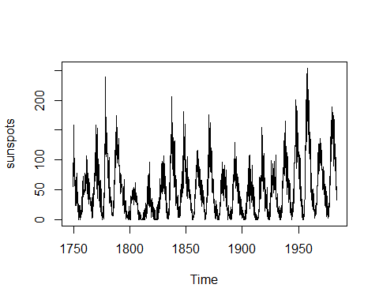

class(sunspots)

## [1] "ts"

#cycle(sunspots)  
  
frequency(sunspots)

## [1] 12

m <- lm(sunspots ~ time(sunspots))  
plot(m)

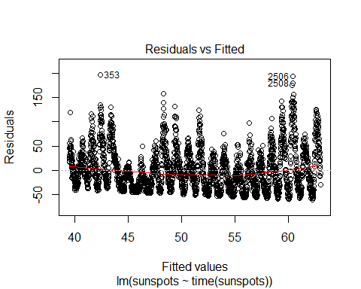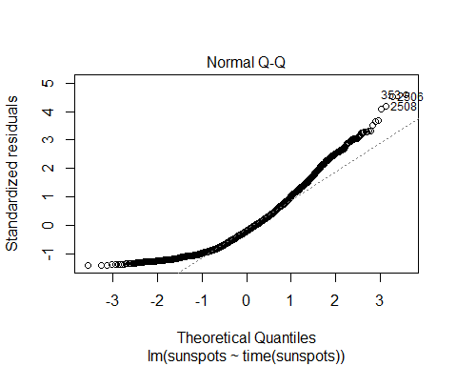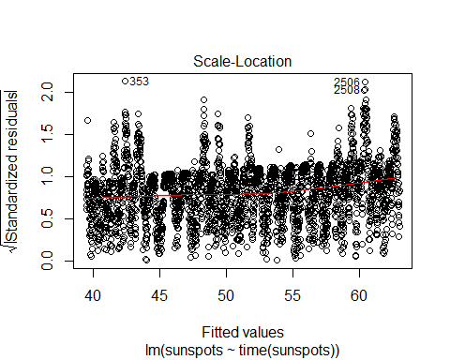

abline(m)

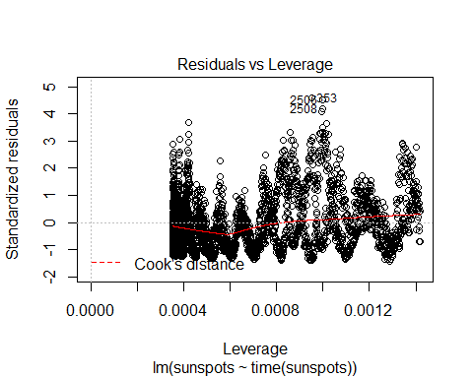

plot(aggregate(sunspots, FUN = mean))

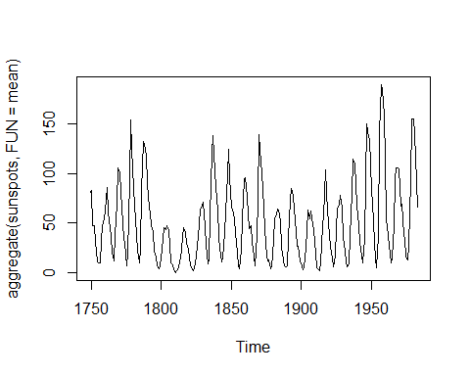

**Q. Plot the monthly (or other suitable periodic) boxplots**

boxplot(sunspots ~ cycle(sunspots))

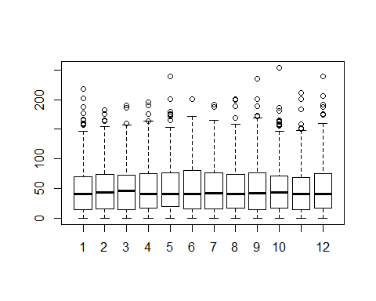

**Q. Decompose the time series using the stl function. What type of trend does it show?**

**Answer:** The plot is showing yearly seasonal trend.

d <- stl(sunspots, s.window = 12)  
  
plot(d)

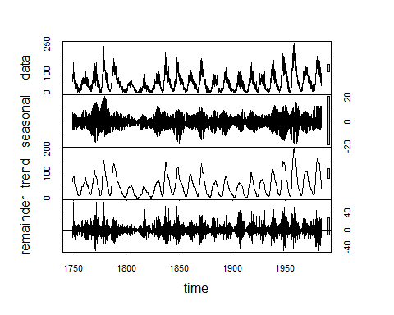

**Q. What type of seasonality?**

**Answer:** Seasonality is a characteristic of a time series in which the data experiences regular and predictable changes that recur every calendar year. Any predictable fluctuation or pattern that recurs or repeats over a one-year period is said to be seasonal.

Seasonal effects are different from cyclical effects, as seasonal cycles are observed within one calendar year, while cyclical effects, such as boosted sales due to low unemployment rates, can span time periods shorter or longer than one calendar year.

**Q. How is the residue after you remove trend and seasonality?**

**Answer:** It gives the graph with “remainder” which is basically showing noise. There are periodic ups and downs.

mean(sunspots)

## [1] 51.26596

g <- rollmean(sunspots, k = 100)  
plot(g)

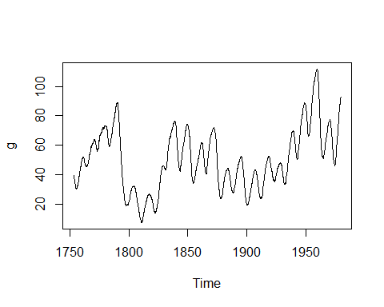

**Q. Build a model of the data using the HoltWinters method for the period upto about 75% of the data (e.g., up to December 2015 if it were for the CO2 data set). Use suitable values of alpha, beta and gamma.**

require(graphics)  
  
  
library(zoo)  
sunspots_zoo <- as.zoo(sunspots)  
zoo_75 <- sunspots_zoo[1:2112]  
zoo_25 <- sunspots_zoo[2113:length(sunspots)]  
  
df_75 <- as.ts(zoo_75)  
df_25 <- as.ts(zoo_25)  
#df_25

**Q. Try to fine tune the model by changing alpha, beta and gamma.**

**Are you able to improve the model (i.e., get a lower rms error)?**

sunspotsPredict <- HoltWinters(df_75, alpha = 0.4856207, beta = 0.001282363, gamma = 0.1589522)

**Q. Predict the values for the next 25% of the time (e.g., for the CO2 data set, all of 2016 and the first 3 months of 2017).**

p <- predict(sunspotsPredict, 708, prediction.interval = TRUE)  
plot(sunspotsPredict, p)

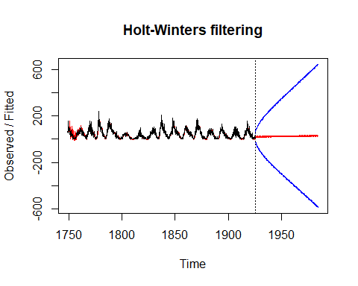

#p  
p_zoo <- as.zoo(p)  
  
p_df <- p[, 'fit']  
  
#p_df <- subset(p, select = c(fit))  
#p_df  
  
class(p_df)

## [1] "ts"

plot(sunspotsPredict)

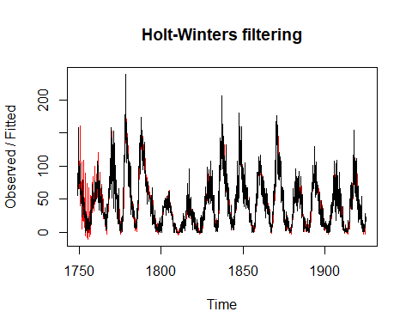

**Q. Plot the predicted values along with the actual values to compare them.**

fitted <- matrix(p_df, ncol = 12, byrow = FALSE)  
#fitted  
  
matrix_df_25 <- as.matrix(df_25)  
#matrix_df_25  
actual <- matrix(matrix_df_25, ncol = 12, byrow = FALSE)  
#actual  
  
#rms <- actual - fitted  
#rms

**Q. Compute the rms error between the predicted and actual values.**  
  
RMSE = function(fittd, actual){  
 sqrt(mean((fitted - actual)^2))  
}  
  
RMSE(fiited, actual)

## [1] 68.75884

plot(df_25, col = "red")  
lines(p_zoo$fit, col = "green")

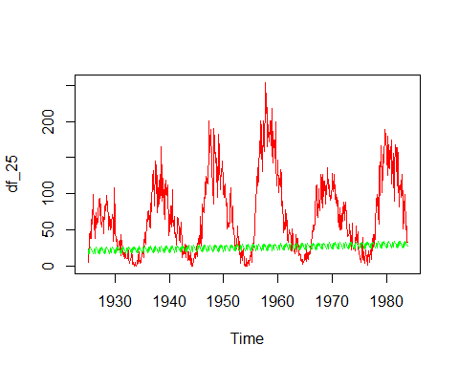

class(df_75)

## [1] "ts"

library(forecast)  
  
components.ts = decompose(sunspots)  
plot(components.ts)

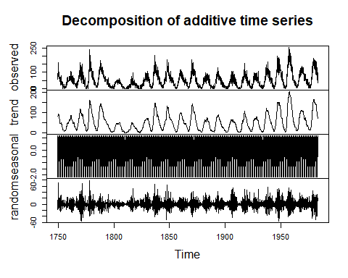

library("fUnitRoots")

## Warning: package 'fUnitRoots' was built under R version 3.5.3

## Loading required package: fBasics

## Warning: package 'fBasics' was built under R version 3.5.3

urkpssTest(sunspots, type = c("tau"), lags = c("short"),use.lag = NULL, doplot = TRUE)

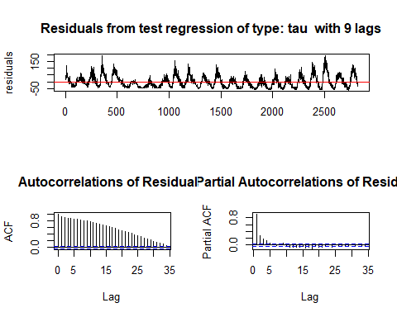

##   
## Title:  
## KPSS Unit Root Test  
##   
## Test Results:  
## NA  
##   
## Description:  
## Fri May 03 15:33:17 2019 by user: IIIT

ts_stationary = diff(sunspots, differences=1)  
plot(ts_stationary)

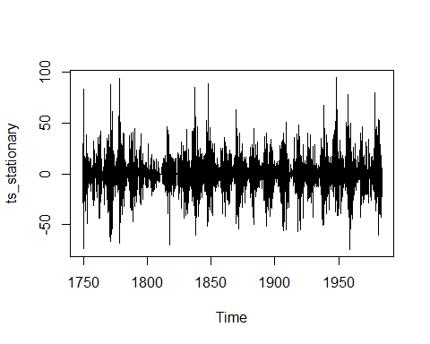

#autoCorrelation : no linear association between observations separated by larger lags  
acf(sunspots,lag.max = 34)

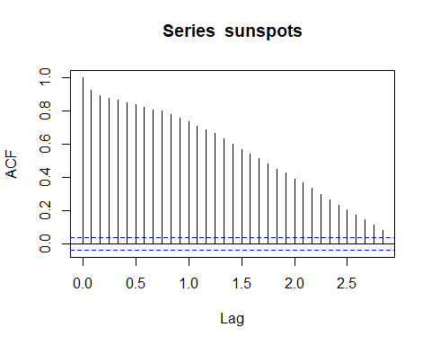

#Remove seasonality from the original series  
ts_seasonallyAdjusted <- sunspots- components.ts$seasonal  
ts_stationary <- diff(ts_seasonallyAdjusted, differences=1)  
  
plot(ts_seasonallyAdjusted)

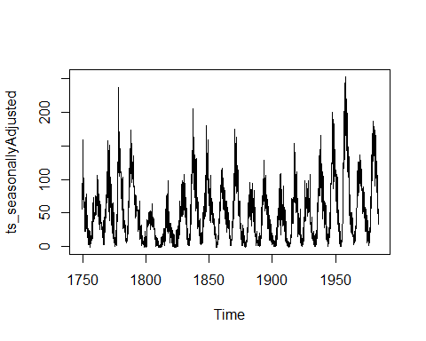

acf(ts_stationary, lag.max = 34)

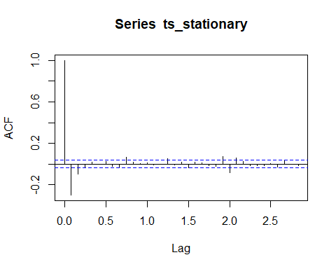

pacf(ts_stationary, lag.max = 34)

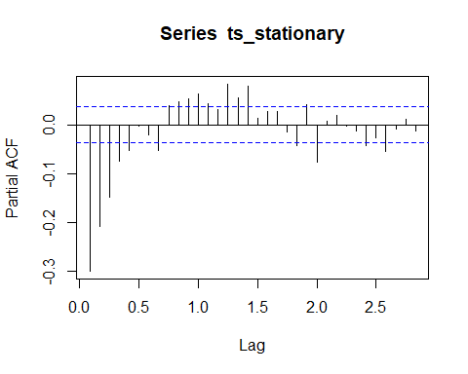

**Q. Build an ARIMA model for the period up to about 75% of the data (e.g., for the CO2 data, up to December 2015) using auto.arima()**

#order: non-seasonal part(p, d, q)  
#seasonal: seasonal part of ARIMA  
#method: fitting model  
fitARIMA <- arima(df_75, order=c(1,1,1),seasonal = list(order = c(1,0,0), period = 12),method="ML")  
library(lmtest)  
coeftest(fitARIMA)

##   
## z test of coefficients:  
##   
## Estimate Std. Error z value Pr(>|z|)   
## ar1 0.216614 0.035463 6.1082 1.007e-09 ***  
## ma1 -0.666507 0.025750 -25.8839 < 2.2e-16 ***  
## sar1 0.041316 0.022328 1.8504 0.06425 .   
## ---  
## Signif. codes: 0 '***' 0.001 '**' 0.01 '*' 0.05 '.' 0.1 ' ' 1

confint(fitARIMA)

## 2.5 % 97.5 %  
## ar1 0.147108523 0.28611988  
## ma1 -0.716975463 -0.61603784  
## sar1 -0.002445492 0.08507695

acf(fitARIMA$residuals)

**Q.** **Predict the values for the next 15 months (e.g., for the CO2 data, all of 2016 and the first 3 months of 2017).**

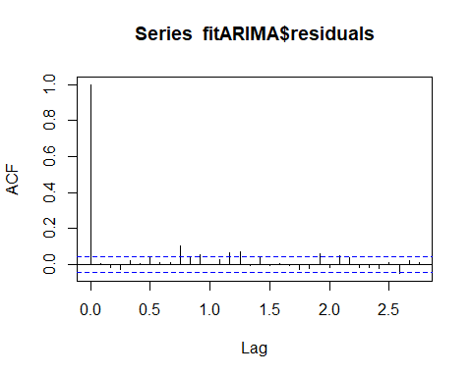

library(FitAR)

## Warning: package 'FitAR' was built under R version 3.5.3

## Loading required package: lattice

## Loading required package: leaps

## Warning: package 'leaps' was built under R version 3.5.3

## Loading required package: ltsa

## Loading required package: bestglm

## Warning: package 'bestglm' was built under R version 3.5.3

##   
## Attaching package: 'FitAR'

## The following object is masked from 'package:forecast':  
##   
## BoxCox

boxresult<-LjungBoxTest (fitARIMA$residuals,k = 2, StartLag = 1)  
plot(boxresult[,3],main= "Ljung-Box Q Test", ylab= "P-values", xlab= "Lag")

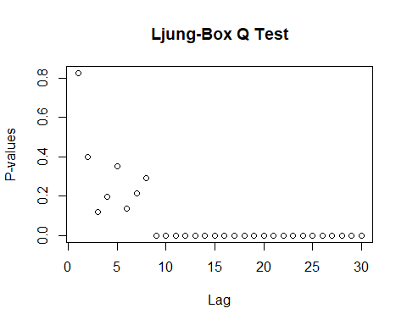

qqnorm(fitARIMA$residuals)  
qqline(fitARIMA$residuals)

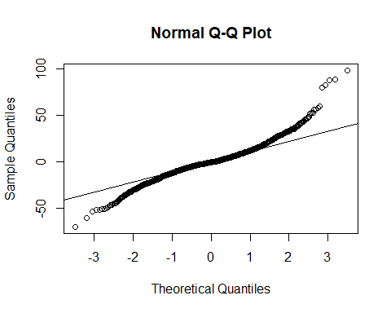

auto.arima(df_75, trace=TRUE)

##   
## Fitting models using approximations to speed things up...  
##   
## ARIMA(2,0,2)(1,0,1)[12] with non-zero mean : 17413.4  
## ARIMA(0,0,0) with non-zero mean : 21324.77  
## ARIMA(1,0,0)(1,0,0)[12] with non-zero mean : 17715.03  
## ARIMA(0,0,1)(0,0,1)[12] with non-zero mean : 19186.54  
## ARIMA(0,0,0) with zero mean : 23183.14  
## ARIMA(2,0,2)(0,0,1)[12] with non-zero mean : 17445.62  
## ARIMA(2,0,2)(1,0,0)[12] with non-zero mean : 17412.53  
## ARIMA(2,0,2) with non-zero mean : 17447.78  
## ARIMA(2,0,2)(2,0,0)[12] with non-zero mean : 17414.74  
## ARIMA(2,0,2)(2,0,1)[12] with non-zero mean : 17416.74  
## ARIMA(1,0,2)(1,0,0)[12] with non-zero mean : 17410.08  
## ARIMA(1,0,2) with non-zero mean : 17445.4  
## ARIMA(1,0,2)(2,0,0)[12] with non-zero mean : 17414.76  
## ARIMA(1,0,2)(1,0,1)[12] with non-zero mean : 17411.24  
## ARIMA(1,0,2)(0,0,1)[12] with non-zero mean : 17443.33  
## ARIMA(1,0,2)(2,0,1)[12] with non-zero mean : 17416.18  
## ARIMA(0,0,2)(1,0,0)[12] with non-zero mean : 18537.75  
## ARIMA(1,0,1)(1,0,0)[12] with non-zero mean : 17437.63  
## ARIMA(1,0,3)(1,0,0)[12] with non-zero mean : 17411.74  
## ARIMA(0,0,1)(1,0,0)[12] with non-zero mean : 18964.08  
## ARIMA(0,0,3)(1,0,0)[12] with non-zero mean : 18351.77  
## ARIMA(2,0,1)(1,0,0)[12] with non-zero mean : 17411.83  
## ARIMA(2,0,3)(1,0,0)[12] with non-zero mean : 17413.13  
## ARIMA(1,0,2)(1,0,0)[12] with zero mean : Inf  
##   
## Now re-fitting the best model(s) without approximations...  
##   
## ARIMA(1,0,2)(1,0,0)[12] with non-zero mean : 17444.48  
##   
## Best model: ARIMA(1,0,2)(1,0,0)[12] with non-zero mean

## Series: df_75   
## ARIMA(1,0,2)(1,0,0)[12] with non-zero mean   
##   
## Coefficients:  
## ar1 ma1 ma2 sar1 mean  
## 0.9806 -0.4383 -0.1127 0.0454 44.7247  
## s.e. 0.0046 0.0220 0.0205 0.0225 7.7248  
##   
## sigma^2 estimated as 225.3: log likelihood=-8716.22  
## AIC=17444.44 AICc=17444.48 BIC=17478.37

arimaPred <- predict(fitARIMA,n.ahead = 708)  
futurVal <- forecast(df_75,h=708, level=c(99.5))  
#forecast(futurVal)  
plot(futurVal)

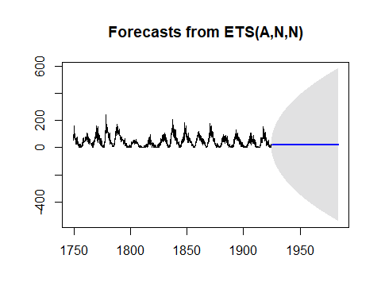

#Arima RMSE

**Q. Compute the rms error between the predicted and actual values.**

diffArima <- (sqrt(mean((df_25 - arimaPred$pred)^2)))  
diffArima

## [1] 72.69348

**Q. Based on your experiment, which method is better and why? HoltWinters or ARIMA?**

**Answer:** In my case HoltWinters method has given better results than ARIMA. The rms error in HoltWinters was 68 whereas it was 72 in case of ARIMA.